**EXERCISE 2 – ENTHALPY**

1. With a partner, discuss the concept of enthalpy and explain what it is in your own words.   
   Enthalpy is the resulting difference in a system’s total chemical energy after a chemical reaction.
2. The enthalpy change of a reaction is usually either positive or negative. Identify and write definitions for these two types of reactions.  
   The total enthalpy of a system after a reaction is calculated by taking the enthalpy of the products and subtracting the enthalpy of the reactants. A positive delta enthalpy signifies an endothermic reaction. In this type of reaction, the system gains energy through absorbing it from its surroundings, meaning the products have more total chemical energy than the reactants. A negative delta enthalpy signifies an exothermic reaction. In an exothermic reaction, the system loses energy to its surroundings by emitting it in the form of heat, meaning the products have less total chemical energy than the reactants.
3. When one mole of gaseous hydrogen peroxide, H2O2, is made from hydrogen and oxygen gases, the enthalpy change is –136 kJ. Identify which of the following correctly represents the thermochemical equation (*may be more than one*).
4. H2 (g) + O2 (g) → H2O2 (g) + 136 kJ
5. H2 (g) + O2 (g) + 136 kJ → H2O2 (g)
6. H2 (g) + O2 (g) → H2O2 (g) Δ*H* = –136 kJ
7. H2 (g) + O2 (g) → H2O2 (g) Δ*H* = +136 kJ
8. Consider the following thermochemical equation:

CaO (s) + H2O (l) → Ca(OH)2 (s) Δ*H* = -66.5 kJ

Which of the following statements is/are correct?

I. The reaction is exothermic

II. The reaction releases 66.5 kJ per gram of Ca(OH)2 (s) formed

III. Alternatively, the ΔH term could be added to the product side of the equation with the appropriate sign

(A) I only

(B) II only

(C) I and II

(D) I and III

(E) I, II, and III

1. Aqueous HCl is added to an aqueous solution of NaOH at 25 °C and the result is shown in the figure below.

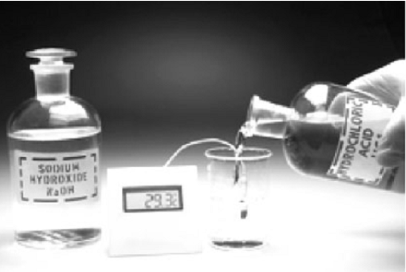

Which of the following correctly characterises this reaction?

(A) The reaction is exothermic.

(B) The Δ*H* for the reaction has a + sign.

(C) Energy could be considered to be a reactant in the equation for the reaction.

(D) The energy (enthalpy) of the products is greater than the reactants.

(E) This reaction consumes energy.

1. The thermochemical equation describing the heat change in the decomposition of limestone, CaCO3, is:

CaCO3 (s) → CaO (s) + CO2 (g) Δ*H* = 1.76 kJ/g

1. Identify whether this is an exothermic or endothermic reaction.  
   Endothermic
2. Draw an enthalpy level diagram for this reaction.
3. Calculate the heat change that accompanies the decomposition of 25.0 g of limestone.  
   1.76 x 25 = +44kJ
4. The metabolism of glucose can be represented by the equation

C6H12O6 (s) + 6O2 (g) → 6CO2 (g) + 6H2O (g) Δ*H* = 15.7 kJ/g

1. Identify whether this is an exothermic or endothermic reaction.  
   Exothermic
2. Draw an enthalpy level diagram for this reaction.
3. How many grams of glucose must be metabolised to produce 282 kJ of energy?   
   282 / 15.7 = 17.96g